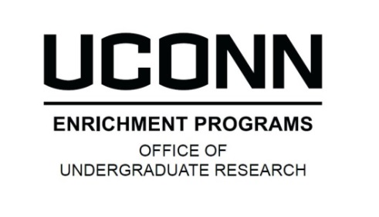
SOCIAL SCIENCES, HUMANITIES, AND ARTS RESEARCH EXPERIENCE (SHARE) AWARD
2018 STUDENT APPLICATION
Please enter answers to the questions below and upload this document as part of the online SHARE application. Your application must be submitted online through
- DEADLINE: 10/23/17 - the OUR website: http://ugradresearch.uconn.edu/share/

APPLICANt Information
Student Name: Click here to enter text.
PROPOSED SHARE PROJECT
Title of Proposed Project: Click here to enter text.
Name of Faculty Mentor: Click here to enter text.
Please enter your responses to the following questions, then save this file as a PDF and upload it as part of your online application.
- What will you be doing in this research project? (500 word maximum)
Click here to enter text.

- Why are you interested in this particular research project? (500 word maximum)
Click here to enter text.

- How do you think participating in this research project will contribute to your educational and career goals? (500 word maximum)
Click here to enter text.

Optional question
Are there additional factors in your background or life experience that would help you benefit from this opportunity? Discuss social, economic, educational, or other obstacles, as appropriate. (500 word maximum)
Click here to enter text.

