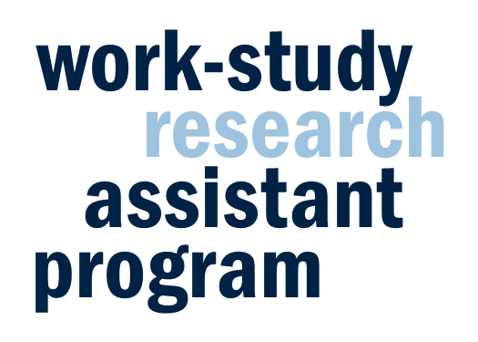
Student Interview & Survey Research Assistant (202)
In order to post a work-study position as part of this program, you must provide a job description and agree to program terms. Please review the job description template below, adding information where requested in italicized text, and deleting or modifying the template text as needed. Make sure to review and agree to the terms at the end of this document.
Faculty Name: Enter here
Faculty Department: Enter here
Brief Position Description: 1-2 sentences that describe the content and nature of this position (i.e., what is your research about?). This description will be used to advertise your position and will help prospective applicants assess whether the position aligns with their interests.
Job Description:
A student in this position will assist faculty in research efforts utilizing survey research techniques.
Research activities may include:
- Schedule interviews
- Conduct interviews
- Mail questionnaires
- Administer questionnaires (by phone, in person, online)
- Collect and record data
- Review forms and/or notes for completeness
- Transcribe from digital recorders and videotapes
- Assist in the preparation of copy for publication
- Read and summarize related literature
- Attend training sessions and staff meetings
- Perform miscellaneous duties as directed
- Add duties here
Requirements for the job:
Students MUST:
- Be an undergraduate student with a Federal work-study award
- Be able to operate computer, phone, and/or other research equipment
- Have excellent communication skills
- Submit a short report detailing research progress during each semester of participation
- Attend two professional development events per semester (e.g., CCD workshop, department colloquium speaker, dissertation defense) and submit a brief reflection report for each
- Present poster about the research experience at a Frontiers in Undergraduate Research exhibition or complete a short reflection paper at the conclusion of the academic year
- Be available at the following specific times…
- Add requirements here
Preferred qualifications:
- Add any additional qualifications here
Application Materials:
The standard application will ask for student name, email, major, anticipated graduation date, availability for fall semester, and a description of relevant experience. Please specify which additional application materials you would like students to provide. A list follows below; please delete any you do not wish to receive.
- Cover Letter
- Resume
- References (Email? Telephone?)
Additional application questions: [please specify]

Please review the program terms below and certify your agreement by typing your name.
By posting a research opportunity through the Work-Study Research Assistant Program and typing my name below I acknowledge and agree to the following:
Students participating in the Work-Study Research Assistant Program differ from other undergraduate researchers whom I may be mentoring due to the following expectations: participation in professional development events identified by the Office of Undergraduate Research, completion of end-of-semester reports, and completion of a reflection requirement (either a reflection paper or a poster presentation at Frontiers).
In accordance with Federal Regulation 34 CFR 675.20(d), students who are employed with Federal Work-Study funds and receiving academic credit for that work will not be:
• Paid less than he or she would be if no academic credit were received;
• Paid for receiving instruction in a classroom, laboratory, or other academic settings; and
• Paid unless the Department/Office would normally pay another person for the same position.

Type name here

