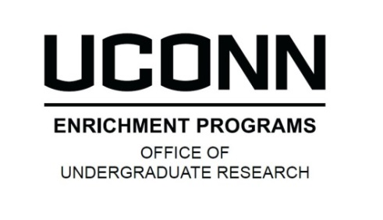
TRANSLATIONAL RESEARCH INTERNSHIP PROGRAM
SUMMER 2016 APPLICATION
Please enter answers to the questions below and upload this document as part of the online Translational Research Internship Program application. Your application must be submitted online through the OUR website:
- DEADLINE: 1/6/16 - http://ugradresearch.uconn.edu/translational-research-internship/

APPLICANt Information
Student Name: Click here to enter text.
PROGRAM APPLICATION
Please enter your responses to the following questions, then save this file as a PDF and upload it as part of your online application.
- Describe your career/post-graduation goals. (300 word maximum)
Click here to enter text.

- Describe any previous research experience and/or laboratory work that may have prepared you for this internship. (500 word maximum)
Click here to enter text.

- Personal Statement: Explain why you are applying to this program. (300 word maximum)
Click here to enter text.

